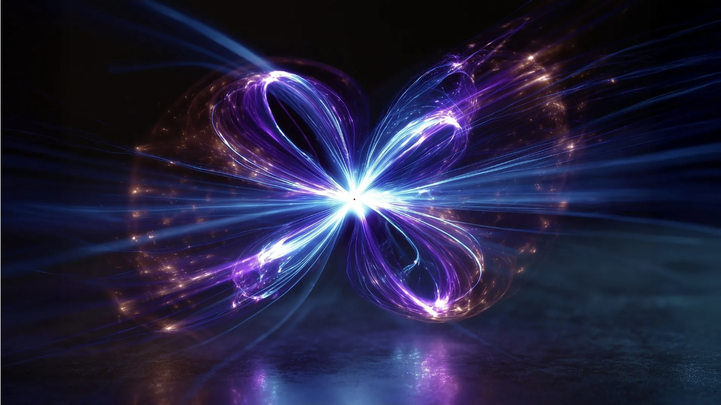
Scientists have discovered a way to make atomic magnets swirl into tiny whirlpools, opening new possibilities for faster, greener electronics and quantum computers. Credit: AI/ScienceDaily.com

A new crystal makes magnetism twist in surprising ways
Date:
January 12, 2026
Source:
Florida State University
Summary:
Florida State University scientists have engineered a new crystal that forces atomic magnets to swirl into complex, repeating patterns. The effect comes from mixing two nearly identical compounds whose mismatched structures create magnetic tension at the atomic level. These swirling “skyrmion-like” textures are prized for their low-energy behavior and stability. The discovery could help drive advances in data storage, energy-efficient electronics, and quantum computing.

Scientists at Florida State University have developed a new type of crystalline material that displays rare and intricate magnetic behavior. The discovery could open new paths toward advanced data storage technologies and future quantum devices.

The findings, published in the Journal of the American Chemical Society, show that blending two materials with nearly identical chemical makeup but very different crystal structures can produce an entirely new structure. This unexpected hybrid crystal exhibits magnetic properties that do not appear in either of the original materials.

How Atomic Spins Create Magnetism

Magnetism begins at the atomic scale. In magnetic materials, each atom behaves like a tiny bar magnet because of a property called atomic spin. Spin can be pictured as a small arrow showing the direction of an atom's magnetic field.

When many atomic spins line up, either pointing the same way or in opposite directions, they generate the familiar magnetic forces used in everyday technologies like computers and smartphones. This type of orderly alignment is typical of conventional magnets.

The FSU team demonstrated that their new material behaves very differently. Instead of lining up neatly, the atomic spins organize into complex, repeating swirl patterns. These arrangements, known as spin textures, strongly influence how a material responds to magnetic fields.

Creating Magnetic Swirls Through Structural Frustration

To produce these unusual effects, the researchers intentionally combined two compounds that are chemically similar but structurally mismatched. Each compound has a different crystal symmetry, meaning the atoms are arranged in incompatible ways.
ates what scientists call structural "frustration," where the system cannot settle into a simple, stable pattern.

"We thought that maybe this structural frustration would translate into magnetic frustration,'" said co-author Michael Shatruk, a professor in the FSU Department of Chemistry and Biochemistry. "If the structures are in competition, maybe that will cause the spins to twist. Let's find some structures that are chemically very close but have different symmetries."

The team tested this idea by combining a compound made of manganese, cobalt, and germanium with another made of manganese, cobalt, and arsenic. Germanium and arsenic sit next to each other on the periodic table, making the compounds chemically similar but structurally distinct.

Once the mixture cooled and crystallized, the researchers examined the result and confirmed the presence of the swirling magnetic patterns they were aiming for. These cycloidal spin arrangements are known as skyrmion-like spin textures, which are a major focus of current research in physics and chemistry.

To map the magnetic structure in detail, the team used single-crystal neutron diffraction measurements collected on the TOPAZ instrument at the Spallation Neutron Source. This U.S. Department of Energy Office of Science user facility is located at Oak Ridge National Laboratory.

Why These Magnetic Patterns Matter

Materials that host skyrmion-like spin textures have several promising technological advantages. One potential use is in next-generation hard drives that store far more information in the same physical space.

Skyrmions can also be moved using very little energy, which could significantly reduce power demands in electronic devices. In large-scale computing systems with thousands of processors, even modest efficiency gains can translate into major savings on electricity and cooling.

The research may also help guide the development of fault-tolerant quantum computing systems. These systems are designed to protect delicate quantum information and continue operating reliably despite errors and noise -- the holy grail of quantum information processing.

"With single-crystal neutron diffraction data from TOPAZ and new data-reduction and machine-learning tools from our LDRD project, we can now solve very complex magnetic structures with much greater confidence," said Xiaoping Wang, a distinguished neutron scattering scientist at Oak Ridge National Laboratory. "That capability lets us move from simply finding unusual spin textures to intentionally designing and optimizing them for future information and quantum technologies.”

Designing Materials Instead of Searching for Them

Much of the earlier work on skyrmions involved searching through known materials and testing them one by one to see whether the desired magnetic patterns appeared.

This study took a more deliberate approach. Rather than hunting for existing examples, the researchers designed a new material from the ground up, using structural frustration as a guiding principle to create specific magnetic behavior.

"It's chemical thinking, because we're thinking about how the balance between these structures affects them and the relation between them, and then how it might translate to the relation between atomic spins," Shatruk said.

By understanding the underlying rules that govern these patterns, scientists may eventually be able to predict where complex spin textures will form before making the material.

"The idea is to be able to predict where these complex spin textures will appear," said co-author Ian Campbell, a graduate student in Shatruk's lab. "Traditionally, physicists will hunt for known materials that already exhibit the symmetry they're seeking and measure their properties. But that limits the range of possibilities. We're trying to develop a predictive ability to say, 'If we add these two things together, we'll form a completely new material with these desired properties.'”

gredients. That flexibility may allow researchers to grow crystals more easily, lower costs, and strengthen supply chains for advanced magnetic materials.

Research Experience at Oak Ridge National Laboratory

Campbell completed part of the research at Oak Ridge National Laboratory while supported by an FSU fellowship.

"That experience was instrumental for this research," he said. "Being at Oak Ridge allowed me to build connections with the scientists there and use their expertise to help with some of the problems we had to solve to complete this study."

Florida State University has been a sponsoring member of Oak Ridge Associated Universities since 1951 and is also a core university partner of the national laboratory. Through this partnership, FSU faculty members, postdoctoral researchers, and graduate students can access ORNL facilities and collaborate with laboratory scientists.

Collaboration and Funding

Additional co-authors on the study include YiXu Wang, Zachary P. Tener, Judith K. Clark, and Jacnel Graterol from the FSU Department of Chemistry and Biochemistry; Andrei Rogalev and Fabrice Wilhelm from the European Synchrotron Radiation Facility; Hu Zhang and Yi Long from the University of Science and Technology Beijing; Richard Dronskowski from RWTH Aachen University; and Xiaoping Wang from Oak Ridge National Laboratory.

The research was supported by the National Science Foundation and carried out using facilities at Florida State University and Oak Ridge National Laboratory.

